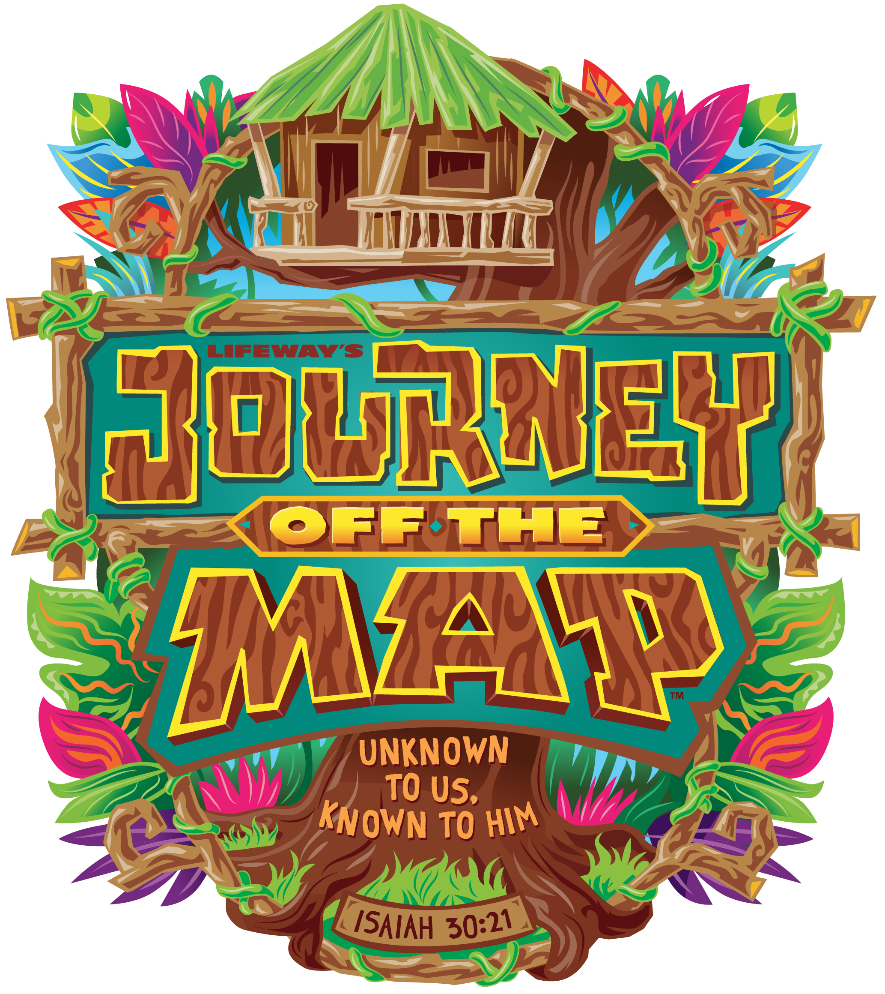
JOURNEY OFF THE MAP
August 10 - 14, 9:30am -12:00pm (daily)
Lake Country Church
JOURNEY OFF THE MAP is for children ages 5-12
Cost: By donation

Child’s name:______________________________ Grade completed:_______
Known Allergies/Medical/Pertinent Information/Would like to be in a group with:
________________________________________________________________
Health Card Number: _________________________________________M / F
_______________________________________________________________________

Child’s name:______________________________ Grade completed:_______
Known Allergies/Medical/Pertinent Information/Would like to be in a group with:
________________________________________________________________
Health Card Number: _________________________________________M / F
_______________________________________________________________________

Child’s name:______________________________ Grade completed:_______
Known Allergies/Medical/Pertinent Information/Would like to be in a group with:
_______________________________________________________________________
Health Card Number: _________________________________________M / F
_______________________________________________________________________
I give permission for the participant(s) named above to attend Journey Off The Map Kids Camp, August 10-14, 2015.
I give consent to the Kids Camp team to use pictures/videos of my child(ren) taken at the event for promotional material and website.
I authorize the ministry staff of Lake Country Church to sign a consent for medical treatment and to authorize any physician or hospital to provide medical assessment, treatment or procedures for the participant(s) named above.
My signature below indicates that I have read and understand the above release.

Parent/Guardian’s Signature___________________________________
Date_______________________________________________________
Please return completed form to:
Lake Country Church, 12025 Oceola Rd., Winfield (250)766-4433

Parent(s)/ Guardian Name:_________________________________________
Address:_________________________________________________________
City:___________________________________ Postal Code:______________
Home phone #:___________________Cell phone #:______________________
Email:___________________________________________________________
Do you regularly attend church? Yes/No If yes, where?____________________
Emergency Contact Number:________________________________________
# attending the free BBQ @ noon Friday, August 14.___________

